Given n and m which are the dimensions of a matrix initialized by zeros and given an array indices where indices[i] = [ri, ci]. For each pair of [ri, ci] you have to increment all cells in row ri and column ci by 1.

Return *the number of cells with odd values* in the matrix after applying the increment to all indices.

**Example 1:**

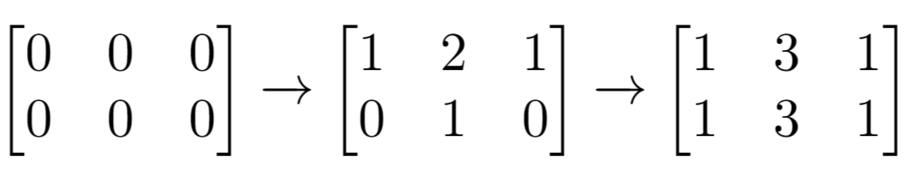

**Input:** n = 2, m = 3, indices = [[0,1],[1,1]]

**Output:** 6

**Explanation:** Initial matrix = [[0,0,0],[0,0,0]].

After applying first increment it becomes [[1,2,1],[0,1,0]].

The final matrix will be [[1,3,1],[1,3,1]] which contains 6 odd numbers.

**Example 2:**

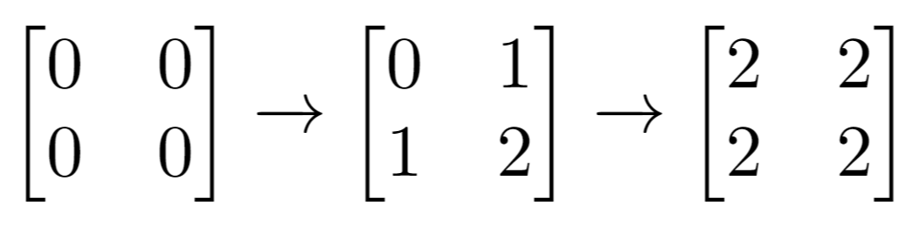

**Input:** n = 2, m = 2, indices = [[1,1],[0,0]]

**Output:** 0

**Explanation:** Final matrix = [[2,2],[2,2]]. There is no odd number in the final matrix.

**Constraints:**

* 1 <= n <= 50
* 1 <= m <= 50
* 1 <= indices.length <= 100
* 0 <= indices[i][0] < n
* 0 <= indices[i][1] < m